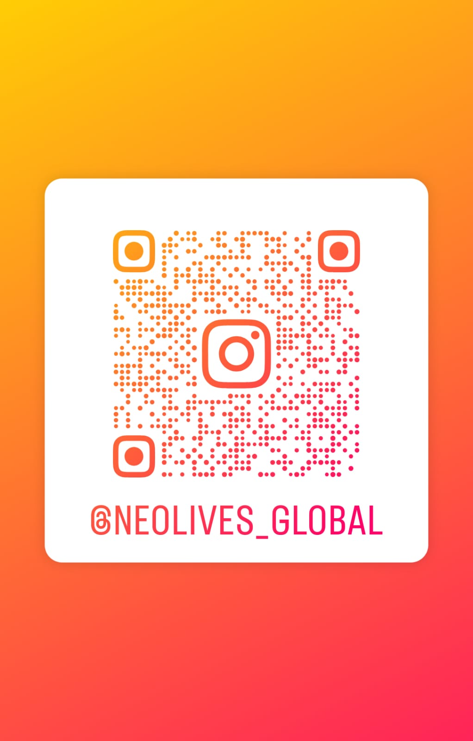
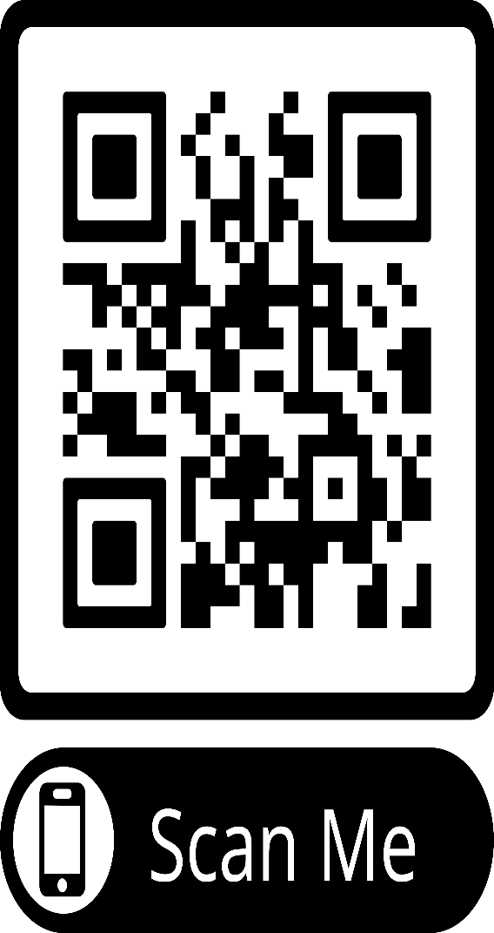

Neolife Wellness Center
Stay connected for expert health guidance,
Ayurveda • Panchakarma • Acupuncture
Naturopathy • Beauty Therapy • Wellness Tips
Follow us on Instagram
Subscribe to our YouTube Channel
Scan the QR Codes

